Required Monthly Investment to Amass $1M - Corrected Full Answer

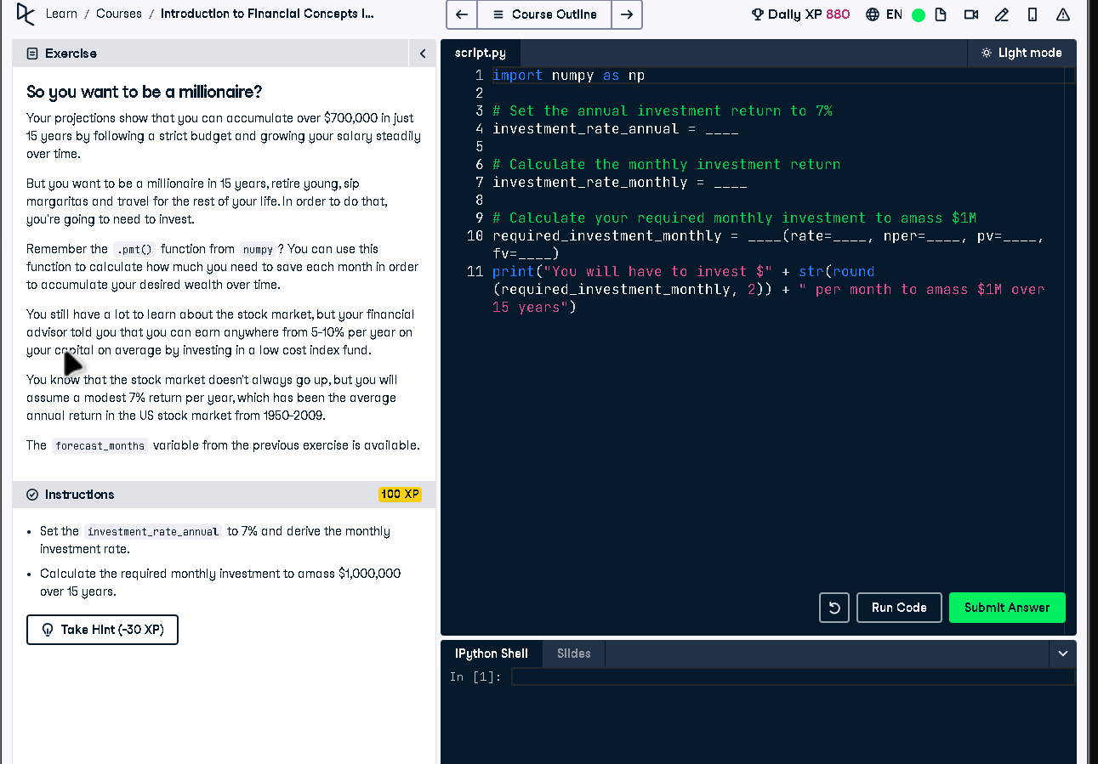

# Full Code Answer:

import numpy as np  
  
# Set the annual investment return to 7%  
investment_rate_annual = 0.07  
  
# Calculate the monthly investment return  
investment_rate_monthly = (1 + investment_rate_annual)**(1/12) - 1  
  
# Calculate your required monthly investment to amass $1M  
required_investment_monthly = np.pmt(rate=investment_rate_monthly, nper=forecast_months, pv=0, fv=-1000000)  
print("You will have to invest $" + str(round(required_investment_monthly, 2)) + " per month to amass $1M over 15 years")

# Question:

How much monthly investment is needed at a 7% annual return to reach $1M in 15 years?

# 20-word Explanation (Question):

Monthly investment planning for $1M involves converting annual returns to monthly and applying payment formulas to determine contributions.

# Answer:

Convert annual return to monthly compounding rate with (1 + annual)^(1/12) - 1, then calculate with np.pmt.

# 20-word Explanation (Answer):

By compounding annual return monthly and using np.pmt with the total periods, we compute required monthly investment precisely.